**Login System**

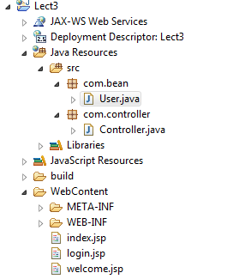

**VIEWS**

**index.jsp**

<%@ page language=*"java"* contentType=*"text/html; charset=ISO-8859-1"*

pageEncoding=*"ISO-8859-1"*%>

<!DOCTYPE html PUBLIC "-//W3C//DTD HTML 4.01 Transitional//EN" "http://www.w3.org/TR/html4/loose.dtd">

<html>

<head>

<meta http-equiv=*"Content-Type"* content=*"text/html; charset=ISO-8859-1"*>

<title>Insert title here</title>

</head>

<body>

<h1>This is Index</h1>

<a href=*"*<%=request.getContextPath() %>*/Controller?action=login"*>Login</a>

</body>

</html>

**login.jsp**

<%@ page language=*"java"* contentType=*"text/html; charset=ISO-8859-1"*

pageEncoding=*"ISO-8859-1"*%>

<!DOCTYPE html PUBLIC "-//W3C//DTD HTML 4.01 Transitional//EN" "http://www.w3.org/TR/html4/loose.dtd">

<html>

<head>

<meta http-equiv=*"Content-Type"* content=*"text/html; charset=ISO-8859-1"*>

<title>Insert title here</title>

</head>

<body>

<h1>Login</h1>

<font color=*"red"*><%=request.getAttribute("msg") %></font>

<form method=*"post"* action=*"*<%=request.getContextPath() %>*/Controller"*>

<input type=*"hidden"* name=*"action"* value=*"login_form"* />

Username: <input type=*"text"* name=*"username"* value=*"*<%=request.getAttribute("username") %>*"*/>

<br><br>

Password: <input type=*"text"* name=*"password"* value=*"*<%=request.getAttribute("password") %>*"*/>

<br><br>

<input type=*"submit"* name=*"submit"* value=*"login"* />

</form>

</body>

</html>

**welcome.jsp**

<%@ page language=*"java"* contentType=*"text/html; charset=ISO-8859-1"*

pageEncoding=*"ISO-8859-1"*%>

<!DOCTYPE html PUBLIC "-//W3C//DTD HTML 4.01 Transitional//EN" "http://www.w3.org/TR/html4/loose.dtd">

<html>

<head>

<meta http-equiv=*"Content-Type"* content=*"text/html; charset=ISO-8859-1"*>

<title>Insert title here</title>

</head>

<body>

Welcome <%=request.getAttribute("username") %>

</body>

</html>

**CONTROLLER**

**Controller.java**

package com.controller;

import java.io.IOException;

import javax.servlet.ServletException;

import javax.servlet.http.HttpServlet;

import javax.servlet.http.HttpServletRequest;

import javax.servlet.http.HttpServletResponse;

import com.bean.User;

/**

* Servlet implementation class Controller

*/

public class Controller extends HttpServlet {

private static final long serialVersionUID = 1L;

protected void doGet(HttpServletRequest request, HttpServletResponse response) throws ServletException, IOException {

String action=request.getParameter("action"); //null

if(action == null){

request.getRequestDispatcher("index.jsp").forward(request, response);

}

else{

doPost(request,response);

}

}

protected void doPost(HttpServletRequest request, HttpServletResponse response) throws ServletException, IOException {

String action=request.getParameter("action"); //login_form

if(action.equals("login")){

request.setAttribute("msg", "");

request.setAttribute("username", "");

request.setAttribute("password", "");

request.getRequestDispatcher("login.jsp").forward(request, response);

}

if(action.equals("login_form")){

String username =request.getParameter("username");

String password = request.getParameter("password");

User user = new User();

boolean status =user.validate(username,password);

if(status == true){

request.setAttribute("username", username);

request.getRequestDispatcher("welcome.jsp").forward(request, response);

}

else{

request.setAttribute("username", username);

request.setAttribute("password", password);

request.setAttribute("msg", "Invalid Username/Password");

request.getRequestDispatcher("login.jsp").forward(request, response);

}

}

}

}

**BEAN**

**User.java**

**package** com.bean;

**import** java.util.HashMap;

**public** **class** User {

**private** HashMap<String,String> map = **new** HashMap<String,String>();

**public** **boolean** validate(String username,String password){

populate();

**for**(String email : map.keySet()){

**if**(email.equals(username)){ //john@gmail.com

String value=map.get(email); //1234

**if**(value.equals(password)){

**return** **true**;

}

**return** **false**;

}

}

**return** **false**;

}

**private** **void** populate(){

map.put("john@gmail.com", "1234");

map.put("geoff@gmail.com", "abcd");

}

}

Output:

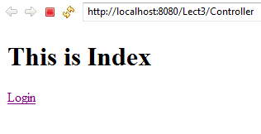

After click on login

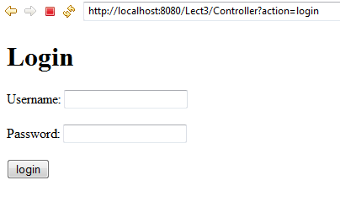

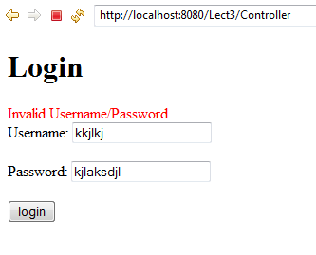

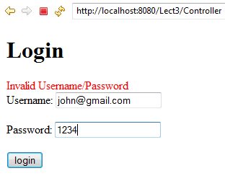

After submitting the form

